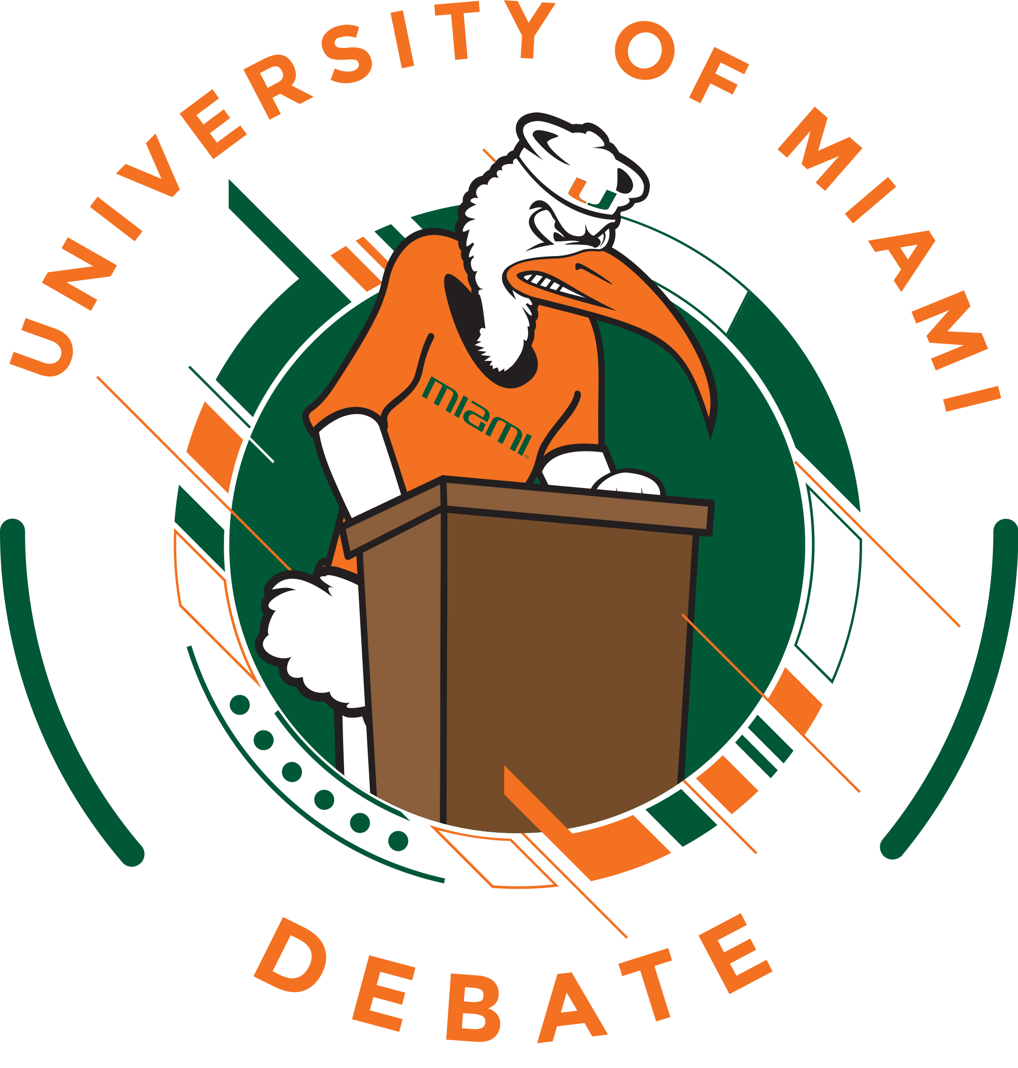

On behalf of the University of Miami Debate Team and the UM School of Communication, we are pleased to invite student debaters of all experience and skill levels to participate in a debate tournament and civic debate event on our campus on Saturday, Earth Day, April 22 – Sunday, April 23, 2023. We will offer four preliminary rounds of debate and appropriate elimination rounds up to quarterfinals.

Topic

“Acceleration of open ocean aquaculture development would be desirable.”

We will share a non-binding topic statement and limited bibliography with you by March 1. It is our hope that the topic will encourage research, thought, and discourse about the vital and urgent need to preserve ocean health and resources while generating sustainable food sources for a planet facing multiple crises.

Affiliation

The Oceans Debates are a civic debate education program intended to be consistent with the aims of the Civic Debate Conference.

Format
The debates will be public in style with a goal of attracting media attention and local participation. The format and approach, therefore, is designed to be suitable for a public audience and accessible to student debaters regardless of experience. Persuasive delivery style and appropriate argument selection for non-expert audiences will be rewarded. To this end, we will use the format originated by the Lafayette Debates and adopted by the Social Justice Debates, a hybrid between intercollegiate policy and parliamentary formats, and very accessible for audience debates.
Students will compete in teams of two debaters each. Teams will be assigned to affirm or negate the topic, with each team representing the affirmative in two debates and the negative in two debates.
Each speaker will give one 6-minute speech, be cross examined for 4 minutes, and cross examine an opposing debater for 4 minutes. In addition, one speaker for each team will also give a 6-minute closing rebuttal:
1st Affirmative 6 Minutes
Cross examination by 2nd Negative Speaker, 4 minutes
1st Negative 6 minutes
Cross examination by 1st Affirmative Speaker, 4 minutes
2nd Affirmative 6 minutes
Cross examination by 1st Negative Speaker, 4 minutes
2nd Negative 6 minutes
Cross examination by 2nd Affirmative Speaker, 4 minutes
2 minutes of preparation time
Affirmative Rebuttal 6 minutes
2 minutes of preparation time
Negative Rebuttal 6 minutes

Community Judging: While the judges supplied by the tournament participants will serve as the judges for the preliminary debates, we plan to recruit content area experts, ocean and environmental educators, activists and professionals, and others interested in the issues of aquaculture and ocean health and/or public advocacy and public speaking to serve as the judges for the semifinal and final rounds.

Fees and Judging: Fees will be $50 per person (for all debaters, coaches, judges and observers) to defray the cost of awards, rooms, breakfast on Saturday and Sunday, lunch on Saturday, and snacks. You must provide judging to cover your teams @ 2 rounds of judging provided for each team entered. All judges will be obligated through Quarterfinals. Teams may not participate if they cannot supply judging. University of Miami students will be allowed to participate and will be eligible to receive awards. If the fees and/or judging requirements create a hardship for you, please communicate with David Steinberg (dave@miami.edu) about your situation asap. We want you to be able to participate and will work with you. A credit card portal will be available for payment.

Registration. Please register for the tournament at Tabroom.com. The deadline for registration is EOD April 14, however, please enter as early as possible even if your entry is tentative to help us in planning. Or just let Dave know you are thinking about attending. Registration will open on Monday, 2/20. If the tournament reaches 40 teams, registration may have to be closed, so please register early.

Hotels: We will not be arranging a block, however, you may secure UM rates at local hotels through the University Travel Site. Please make your reservations as soon as possible, this is Miami. For value and convenience, we recommend these hotels (today’s UM guest rates for a double are listed):

AC Hotel Dadeland. ($174)
Aloft Miami Dadeland ($119)
Courtyard Marriott Dadeland ($122)
Miami Marriott Dadeland ($139)
Four Points by Sheraton Coral Gables ($149)
Hampton Inn by Hilton Coconut Grove ($159)

Directions: For directions to The University of Miami, and campus maps, visit Directions and Maps. The School of Communication is located at 5100 Brunson Drive, Coral Gables, FL 33124-2105.
Parking: You will be required to pay for on-campus parking through PayByPhone or a Pay Station. See University of Miami Visitor Parking for more detailed information and maps.
Tournament Operation:
All participants debate at the invitation of the University of Miami according to its tournament rules and the rules the University holds generally for conduct of guests while on campus. The tournament will in general, attempt to follow the guidelines of the American Forensic Association Code of Standards related to tournament operation and contestant, judge, and coach conduct. Students must have the approval of their institution to compete. Please forward your questions about format, tournament operation, etc. to David Steinberg at dave@miami.edu or 786-351-3813.
The University of Miami is a tobacco free campus.
Equity/ Title IX: The University of Miami Debate Team seeks to foster an environment where all competitors, judges and guests feel welcome and safe. We encourage you to help us in this endeavor. The University of Miami’s Title IX Office, guidelines, and complaint procedures can be located at Title IX.

Accessibility: If you need accommodations, please contact David Steinberg. All our classrooms are wheelchair accessible. We will designate a Quiet Room to allow participants to relax and regain composure. Upon request, we will provide a breastfeeding room. There are gender neutral bathrooms on campus. We can provide a list of rental car and car services that accommodate wheelchairs. The University of Miami’s Office of Disability Services (ODS) is in the Camner Center for Academic Resources in The Whitten University Center N201. ODS staff can be reached at 305-284-2374 (Voice), 305-284-3401 (TDD).
Eligibility: The tournament is open to any undergraduate student seeking a degree from an accredited academic institution. Students must have the approval of their institution to compete and have a faculty advisor/official coach available for questions or concerns.

Tentative Schedule (times approximate)

Saturday, April 22, 2023

9:00 Registration, Breakfast, Mandatory Judge and Competitor Briefing
9:30 Round I
11:15 Round II
Lunch (provided by UM)
1:30 Round III
3:30 Round IV
5:30 Quarterfinals

Sunday, April 23, 2023

10:00 Breakfast
10:30 Semifinals
12:00 Finals
1:30 Presentation of Awards

We sincerely hope you will join us in Miami for the Bill Todd Debates. Do not hesitate to contact us if we can answer questions or help in any way. Sincerely,

David L Steinberg

Director of Debate

dave@miami.edu

Patrick Waldinger

Assistant Director of Debate
waldinger@miami.edu

Bradley Lott
President UM Debate Team
bml91@miami.edu

